Mid-West University

Examinations Management Office
End-Semester Examinations -2080
Bachelor level / B.E. Civil / 2nd Semester Full Marks: 50
Time: 3 hours Pass Marks: 25
Subject: Basic Electronics Engineering (EX421/EX101)
- Attempt all the questions
- Figures in the margin indicate full marks.
- Assume suitable values, with a stipulation, if necessary.
- Candidates are required to answer the questions in their own words as far as possible.
1. a. | Why are resistors, inductors and capacitors called passive elements? What do you mean by  an ideal voltage Source? | [2]
b. | Find current flow in 3Ω resistance. Use superposition theorem to solve the problem.  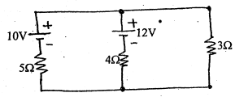 | [4]
2. a. | Explain the modeling of diode forward biasing. Draw the output waveform of full wave rectifier. | [3]
b. | Find the current $I_{Z}$, assuming $V_{Z}=9v$.  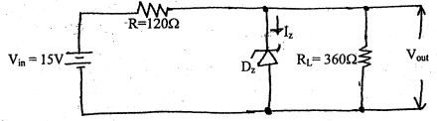 | [4]
3. a. | Explain the structure and operation of enhancement type MOSFET. | [3]
b. | For the given circuit β=100, determine $I_{B},I_{C}$ and $V_{CE}$ for the circuit given below.  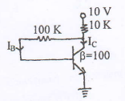 | [4]
4. a. | State any four important properties of ideal Op-Amp. Draw the circuit diagram of differentiator using Op-amp and show the output. | [2+3]
b. | How do you define positive feedback? Draw the circuit for square wave generator and explain the principle of operation. | [1+3]
5. a. | Differentiate between FM and AM communication. Draw and label the diagram of Optical fiber. | [3]
b. | Define communication system. And describe communication system in brief with the complete block diagram. | [3]
6. a. | Simplify the expression using K-Map, F(X,Y,Z) = X'YZ+X’Y'Z+XYZ and realize it using logic gates. | [3]
b. | Mention the types of flip-flops and explain the operation of J-K flip-flop with necessary diagram. | [4]
c. | State De-Morgan's theorems with example in each case. | [3]
7. a.  b. | What is instrumentation system? Describe the instrumentation system with block diagram.  Explain briefly about remote control. | [3]  [2]

The End

