Mid-West University

Examinations Management Office
End-Semester Examinations -2080
Bachelor level / B.E. Civil / 2nd Semester Full Marks: 50
Time: 3 hours Pass Marks: 25
Subject: Basic Electrical Engineering (EL421/EL101)
- Attempt all the questions
- Figures in the margin indicate full marks.
- Assume suitable values, with a stipulation, if necessary.
- Candidates are required to answer the questions in their own words as far as possible.
1. | a) | Differentiate between electromotive force and potential difference. The resistance of a  certain length of a wire is 8 Ω at 30ºC and 5.88 Ω at 90ºC. Determine;  - The temperature coefficient of resistance of the wire at 0ºC.  - The resistance of the wire at 70ºC. | [2]  [3]
 | b) | Define node, junction, branch, mesh and loop. Find the voltage across 5 ohm and 2 ohm  resistor of the network shown in figure below using nodal analysis Method. | [2+4]
2. | a) | Determine the voltage across 10 Ω resistor of the network shown in figure below using  Thevenin's theorem. | [5]
 | b) | State and prove maximum power transfer theorem. | [4]
3. | a) | Determine the average and rms value of the given triangular waveform.  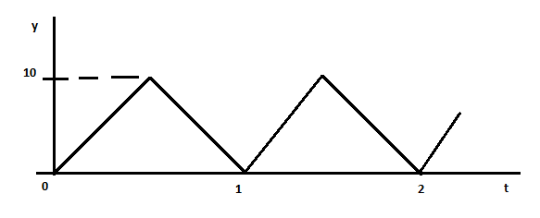 | [2+2]
 | b) | A coil of resistance 8 Ω and inductance of 0.1H is connected in series with a capacitance of 160 µF across applied voltage of 230 V, 50Hz supply. Calculate the followings:  - power factor  - impedance of the circuit  - expression of i(t)  - active, reactive and apparent power  - draw the phasor diagram and state whether the circuit is inductive or capacitive.  Give reasons | [1]  [1]  [1]  [1.5]  [1.5]
4. | a) | Explain in detail, the ac through purely inductive circuit and also derive the equation of  power with required waveform. | [5]
 | b) | A 220 V, three phase voltage is applied to a balanced delta connected three phase load  of phase impedance (20 + j25) Ω calculate;  - the phase voltage  - the phasor current in each line  - active, reactive and apparent power per phase  - draw the phasor diagram  - total active, reactive and apparent power | [1]  [1]  [1.5]  [1]  [0.5]
5. | a) | Define transformer. Explain the operating principle of transformer. | [2+3]
 | b) | Explain the working principle of generator and derive the emf equation of dc generator. | [2+3]

The End

